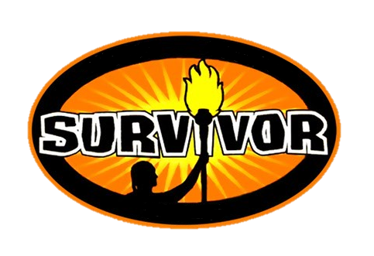

TEAM NAME: __________________________________________________________

Player #1: _____________________________________________________________
Email: ____________________________ Phone# _______________________
Player #2: _____________________________________________________________
Email: ____________________________ Phone# _______________________
Player #3: _____________________________________________________________
Email: ____________________________ Phone# _______________________
Player #4: _____________________________________________________________
Email: ____________________________ Phone# _______________________
Player #5: _____________________________________________________________
Email: ____________________________ Phone# _______________________
Player #6: _____________________________________________________________
Email: ____________________________ Phone# _______________________
Raffle license # 445344

BOOZE

ENTRY FORM
BOOZE SURVIVOR OFFICIAL RULES

- Each person you recruit will be a member of a 6-person team. Each member of the team donates $25 to participate as well as a 26oz. bottle of their choice OR a bottle of wine (approx. value of $25) OR a $25 liquor store gift card. Collect $50 and buy the bottle for the people on your team that are out of town or too busy! If you have extra people that do not form a full team – no worries – we will bundle up teams for you!
- Teams can enter by printing out the entry form from our website (www.vermilionminorhockey.com) or on our Facebook page. Entries will be accepted until February 2nd, 2018 with drop offs happening at the Vermilion Stadium every Monday & Wednesday from January 15th – 31st between 6-9pm. Participants are responsible for completing the entry form, collecting the cash & bottles before dropping off.
- Starting February 3rd, individual names will be eliminated but as long as 1 team member from your team is still in the draw, your team is safe! Once all 6 names have been pulled, your team is eliminated. Within 7 days everyone will be eliminated but the final teams.
- We will be sending out a daily email with the list of people who are eliminated. As well as posting on our BOOZE Survivor Facebook Group.
- The final draw will take place on February 9th. Prizes will be dependent on how many teams are entered. For example:
66 teams enter =
- Participants need to be 18 years of age or older.
- You do not need to be a member of VMHA to participate!! Everyone is welcome…the more, the merrier!!
- Cash and cheques (made out to Vermilion Minor Hockey Association) for entry fees only.
- You can be on multiple teams and so can your recruits. The more teams you are on, the better your odds of winning!!
- Have fun & may the best SURVIVOR TEAM win!!

